Venue- LMC Office

Sederunt
- Drs Katie Adair, Sally Al-Agilly, Michael Anderson, Harminder Baryah, Gouri Bhat, Ronnie Burns, Pearce Cusack, , Mark Fawcett, Helen Fox, Sheena Fraser, Georgi Georgiev, Parisa Ghanbari, Ewan Gray, Peter Horne, Lynn Howie, John Ip, Catherine Johnston, Waseem Khan, Susan Langridge, Gillian Leslie, Allan MacRae, Christopher Mansbridge, Chris McHugh, Brian Milmore, Patricia Moultrie, Austin Nichol, Max Peluso, Scott Queen, Michael Rennick, Harriet Rushworth, Stacy Russell, Victoria Shotton, Jasmeet Singh, Alastair Taylor, David Taylor and Karen Taylor

Chair
- Dr Mark Fawcett, Chair of the Committee

Attending
  - Elaine McLaren, Administration Officer for the Committee
  - Marco Florence, Secretary to the Committee

Apologies
- Drs Maureen Byrne, Gayle Dunnet, Joanna Hall, Sarah Johansen, John Kyle, Dawn Rees, Mark Storey and Graham Thompson; Dr Ron Alexander, Christine Laverty, Dr Kerri Neylon and Allen Stevenson
- Members were reminded to declare any relevant conflicts of interest.
CTAC Presentation, Anne Mitchell, Head of Older People & Primary Care Services, Glasgow City HSCP, South & Morag Lynagh, Senior Nurse Manager, West Dunbartonshire HSCP
24/40
- A presentation on the delivery of CTAC services was provided to the GP Subcommittee, followed by questions from members.
- It was noted that HSCPs had very different starting points including legacy treatment room services in some areas of the board.
- Joined up IT systems with general practice systems is key for information flows
- The importance of capturing the data around the practice workload that has not been transferred to CTAC to inform further progress of delivery was also highlighted.

Minutes GP Subcommittee
24/41
      - Draft Minutes of the GP Subcommittee, 17th June 2024, Paper GPSub_27
- The draft minutes were approved by the GP Subcommittee.

      - Minutes of the GP Subcommittee’s Executive, 1st July 2024, Paper GPSub_10
      - Minutes of the GP Subcommittee’s Executive, 5th August 2024, Paper GPSub_17
      - Draft Minutes of the GP Subcommittee’s Executive, 2nd September 2024, Paper GPSub_28
- Items 24/41.2-4 were noted by the GP Subcommittee.

Matters Arising
24/42
- There were no matters arising.

GP Practice Workload & Sustainability
24/43
  - GGC GP Sit Rep, 11th June 2024 to 9th September 2024, Paper GPSub_29
Date | 0 | 1a | 1b | 2 | 3 | 4 | 5 | list closures
11/06/2024 | 0 | 132 | 82 | 11 | 0 | 0 | 0 | 7
18/06/2024 | 0 | 131 | 82 | 12 | 0 | 0 | 0 | 8
25/06/2024 | 0 | 131 | 82 | 12 | 0 | 0 | 0 | 8
02/07/2024 | 0 | 131 | 82 | 12 | 0 | 0 | 0 | 8
09/07/2024 | 0 | 131 | 82 | 12 | 0 | 0 | 0 | 8
16/07/2024 | 0 | 131 | 82 | 12 | 0 | 0 | 0 | 8
23/07/2024 | 0 | 131 | 82 | 12 | 0 | 0 | 0 | 8
30/07/2024 | 0 | 132 | 82 | 11 | 0 | 0 | 0 | 8
06/08/2024 | 0 | 131 | 82 | 12 | 0 | 0 | 0 | 8
13/08/2024 | 0 | 131 | 83 | 11 | 0 | 0 | 0 | 8
20/08/2024 | 0 | 130 | 84 | 11 | 0 | 0 | 0 | 8
27/08/2024 | 0 | 130 | 83 | 12 | 0 | 0 | 0 | 9
02/09/2024 | 0 | 130 | 83 | 12 | 0 | 0 | 0 | 9
09/09/2024 | 0 | 130 | 83 | 12 | 0 | 0 | 0 | 9

  - LMC GP Practice Situation Survey, 3rd June 2024 to 2nd September 2024, Paper GPSub_30

Week Beginning | Green | Green % | Amber | Amber % | Red | Red % | Black | Black % | Total Responses
03/06/2024 | 26 | 21.85% | 79 | 66.39% | 13 | 10.92% | 1 | 0.84% | 119
10/06/2024 | 30 | 23.08% | 77 | 59.23% | 21 | 16.15% | 2 | 1.54% | 130
17/06/2024 | 27 | 22.50% | 68 | 56.67% | 22 | 18.33% | 3 | 2.50% | 120
24/06/2024 | 24 | 19.67% | 78 | 63.93% | 19 | 15.57% | 1 | 0.28% | 122
01/07/2024 | 32 | 27.12% | 67 | 56.78% | 19 | 16.10% | 0 | 0.00% | 118
08/07/2024 | 32 | 29.91% | 49 | 45.79% | 24 | 22.43% | 2 | 1.87% | 106
15/07/2024 | 33 | 27.27% | 61 | 50.41% | 26 | 21.49% | 1 | 0.83% | 121
22/07/2024 | 33 | 27.73% | 64 | 53.78% | 31 | 17.65% | 1 | 0.84% | 119
29/07/2024 | 37 | 34.91% | 59 | 55.66% | 10 | 9.43% | 0 | 0.00% | 106
05/08/2024 | 40 | 33.33% | 72 | 60.00% | 7 | 5.83% | 1 | 0.83% | 120
12/08/2024 | 37 | 32.46% | 67 | 58.77% | 10 | 8.77% | 0 | 0.00% | 114
19/08/2024 | 34 | 30.91% | 64 | 58.18% | 11 | 10.00% | 1 | 0.91% | 110
26/08/2024 | 35 | 33.98% | 58 | 56.31% | 9 | 8.74% | 1 | 0.97% | 103
02/09/2024 | 29 | 29.00% | 60 | 60.00% | 10 | 10.00% | 1 | 1.00% | 100

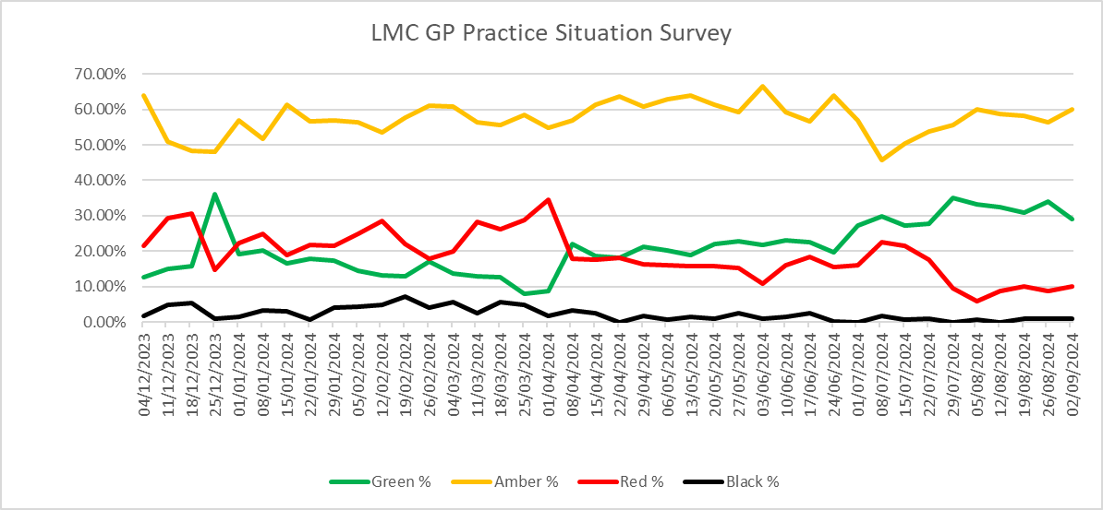
- Items 24/43.1 and 2 were noted by the GP Subcommittee.

  - Appointment of Medical Director, NHS GGC
- Dr Scott Davidson, Deputy Medical Director (Acute Services), has been appointed as the board’s new Medical Director.
- Local Patient Registration Guidance
          - A paper will be taken to SEG recommending the cessation of the local patient registration guidance that has been available for practices to use.
          - If agreed to by SEG, this will mean that all patients, regardless of their local practice registration status, will be able to apply to register unless the practice’s list is closed.
          - The GP Subcommittee has indicated to the board that there may be a rise in the number of practices applying for list closure.

PCIP
24/44
- Primary Care Programme Board, 15th August 2024, Paper GPSub_23
- This paper was noted by the GP Subcommittee.

Notes and Reports from Meetings, Paper GPSub_24
24/45
Report Number | Group | Date of Meeting
1 | Heart MCN Executive | 2nd August 2024
2 | Primary Secondary Care Interface | 7th August 2024
3 | Escalation framework & Contingency Planning Sub group | 8th August 2024
4 | RMG | 13th August 2024
5 | Area Medical Committee | 16th August 2024
6 | ADTC | 19th August 2024
7 | Adult Vaccination Group | 20th August 2024
8 | Non-medicines utilisation sub committee of ADTC | 20th August 2024
9 | GP Editorial Board | 20th August 2024
10 | Medicines Utilisation Subcommittee of ADTC | 21st August 2024
11 | Gender Identity Programme Board | 23rd August 2024
12 | AUC | 27th August 2024
13 | GMS eHealth | 29th August 2024

- This paper was noted by the GP Subcommittee.

Sessional GPs
24/46
- An engagement and networking event for sessional GPs will be held by the GP Subcommittee/LMC on 9th October 2024.

Changes to Medical List, Paper GPSub_26
24/47
- This paper was noted by the GP Subcommittee.

Any Other Business
24/48
- Urology USOC Pathway
- A query was raised regarding the recently published Urology USOC Pathway. The member will provide specific details of their concern to the office.

- Next Meeting of the GP Subcommittee-7.30pm, Monday, 21st October 2024, Teams
- Next Meeting of the GP Subcommittee’s Executive-7.30pm, Monday, 7th October 2024, Teams

