Chief Medical Officer Letter to the Down’s Syndrome Community in Scotland – Easy Read version

What is this easy read about?
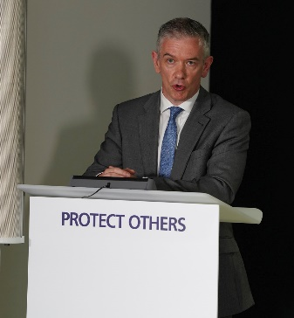 | This is a letter from the Chief Medical Officer of Scotland Dr Gregor Smith
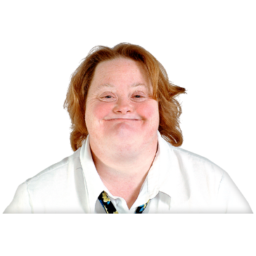 | The letter is being sent to every adult with Down’s Syndrome in Scotland
 | This means every person with Down’s Syndrome who is 18 years old or older
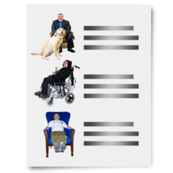 | It means you have been added to something called the shielding list
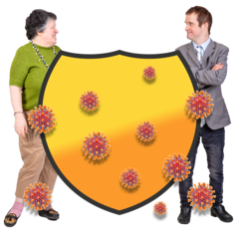 | It does not mean that you need to start shielding
What is the shielding list?
 | At the beginning of the coronavirus pandemic some people were shielding
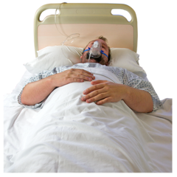 | Shielding was there to protect people who are likely to become very ill from Coronavirus.
 | Shielding meant doing extra things to stay safe like staying at home at all times
 | There is now something called the shielding list
 | Being on the shielding list does not mean that you have to stay at home all the time
 | Being on the shielding list means you will get extra advice and support
Why am I on the shielding list?
 | Experts have been doing research on who has become very ill from coronavirus
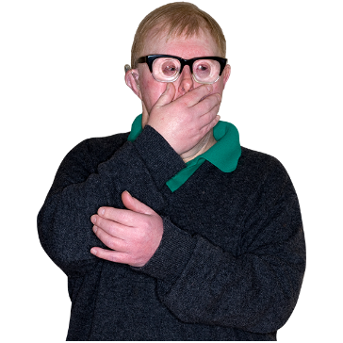 | Their research says that people with Down’s syndrome are more likely to become very ill
 | This is why people with Down’s syndrome are now on the shielding list
What should I do now?
 | You do not have to start shielding or following different rules
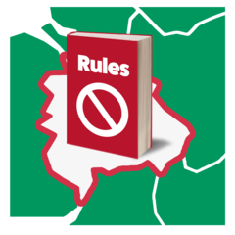 | You should follow the rules in your local area
 | You can find out the local rules in your area at www.gov.scot/coronavirus
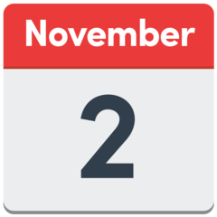 | The new local rules will start on November 2nd
 | Being on the shielding list gives you extra advice and support.
 | Like advice and support for shopping
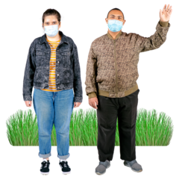 | Like advice and support on seeing other people
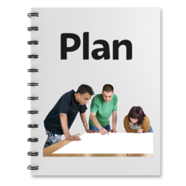 | The Scottish Government will soon send you some information to help you make a personal plan
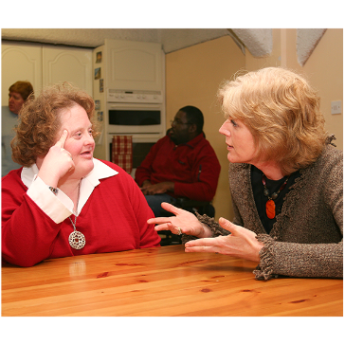 | You can speak to friends and family about what to do
 | You can speak to your doctor
 | If you do not want to be on the shielding list you can ask your GP to take you off the list
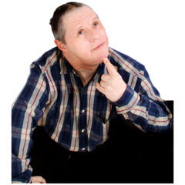 | It is important to think about things and make the right decision for you
Would you like text messages with information?
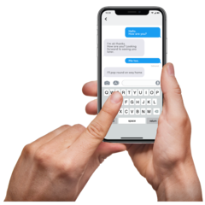 | The Scottish Government can send you text messages to your phone
 | The text messages will have new information and changes
 | If you would like to get them text the red number on your letter to 07860 064525
How else can I get information?
 | The Scottish Government will tell you if you need to start shielding
You can find the latest information at this website:

www.mygov.scot/shielding
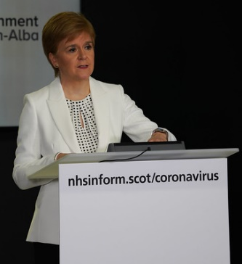 | You can watch the daily briefings from the First Minister
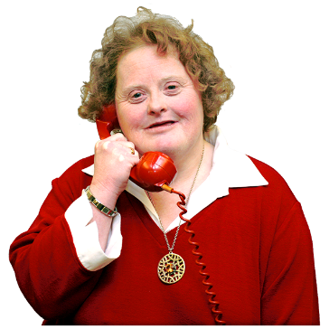 | You can phone the Down’s Syndrome Scotland helpline for more information and support
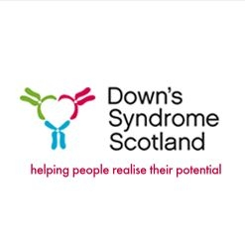 | The number to call Down’s Syndrome Scotland and speak to someone is 0300 030 2121
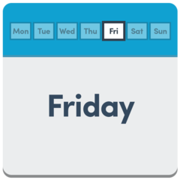  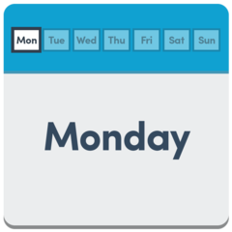  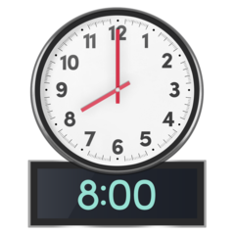 | It is open between 8am and 8pm between Monday and Friday
What about the FACTS advice?
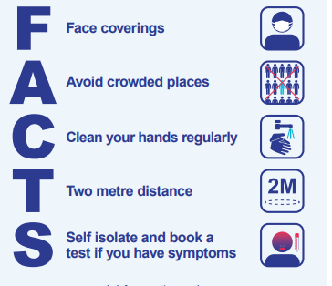 | The Scottish Government want you to remember the FACTS advice
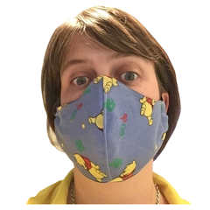 | Wear a face covering
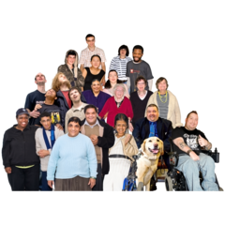 | Avoid crowded places
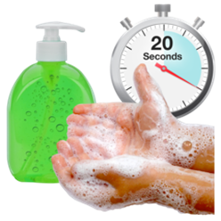 | Clean and wash your hands as often as you can
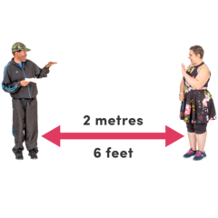 | Stay 2 metres away from people
 | Self-isolate and stay at home if you get symptoms
What about the NHS?
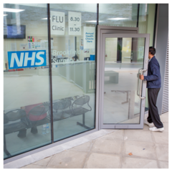 | The NHS is still open to help you
 | You should still go to any appointments that you have
What other things should I think about?
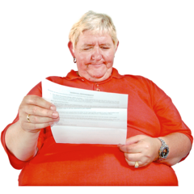 | There was some further information included in the letter sent to you
 | You or a supporter should try to read all of the information but here are some important things
 | You should soon get a letter asking you and anybody you live with to get a flu vaccine
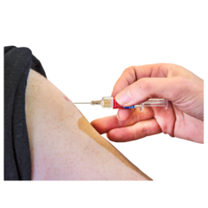 | You should this get this so you can stay safe from the flu
 | If you do not get a letter in the next few weeks call 0800 22 44 88
 | Try and get outside for some exercise if you can
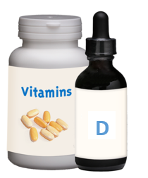 | Try and take some Vitamin D to help your health and wellbeing during winter
Other easy read information can be found at

https://www.nhsinform.scot/translations/formats/easy-read/coronavirus-covid-19

